**Դաս 11**

**Տասնորդական կոտորակների բազմապատկումը**

**Առաջադրանքներ**

**Դասագրքից` 1148, 1150, 1152, 1155**

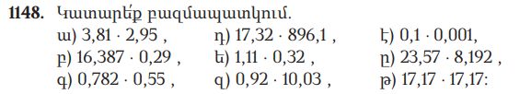

|  |  |  |  |  |  |
| --- | --- | --- | --- | --- | --- |
|  |  |  | 3, | 8 | 1 |
|  |  | x | 2, | 9 | 5 |
|  |  | 1 | 9 | 0 | 5 |
|  | 3 | 4 | 2 | 9 |  |
|  | 7 | 6 | 2 |  |  |
| 1 | 1, | 2 | 3 | 9 | 5 |

|  |  |  |  |  |  |  |
| --- | --- | --- | --- | --- | --- | --- |
|  |  |  | 6, | 3 | 8 | 7 |
|  |  | x | 0, | 2 | 9 |  |
|  | 1 | 4 | 7 | 4 | 8 | 3 |
|  | 3 | 2 | 7 | 7 | 4 |  |
| 0 | 0 | 0 | 0 | 0 |  |  |
|  | 4, | 7 | 5 | 2 | 2 | 3 |

|  |  |  |  |  |  |  |
| --- | --- | --- | --- | --- | --- | --- |
|  |  |  | 0, | 7 | 8 | 2 |
|  | x |  | 0, | 5 | 5 |  |
|  |  |  | 3 | 9 | 1 | 0 |
|  |  | 3 | 8 | 1 | 0 |  |
|  | 0, | 4 | 3 | 0 | 1 |  |
|  |  |  |  |  |  |  |

|  |  |  |  |  |  |  |  |
| --- | --- | --- | --- | --- | --- | --- | --- |
|  |  |  |  | 1 | 7, | 3 | 2 |
|  | x |  | 8 | 9 | 6, | 1 |  |
|  |  |  |  | 1 | 7 | 3 | 2 |
|  |  | 1 | 0 | 3 | 9 | 2 |  |
|  | 1 | 3 | 8 | 5 | 6 |  |  |
| 1 | 5 | 5 | 2 | 0, | 4 | 5 | 2 |

|  |  |  |  |  |  |
| --- | --- | --- | --- | --- | --- |
|  |  |  | 1, | 1 | 1 |
|  |  |  | 0, | 3 | 2 |
|  |  |  | 2 | 2 | 2 |
|  |  | 3 | 3 | 3 |  |
| 0 | 0 | 0 | 0 |  |  |
|  | 0, | 3 | 5 | 5 | 2 |

|  |  |  |  |  |  |  |
| --- | --- | --- | --- | --- | --- | --- |
|  |  |  |  | 0, | 9 | 2 |
|  |  |  | 1 | 0, | 0 | 3 |
|  |  |  |  | 2 | 7 | 6 |
|  |  |  | 0 | 0 | 0 |  |
|  |  | 0 | 0 | 0 |  |  |
|  | 0 | 9 | 2 |  |  |  |
|  |  | 9, | 2 | 2 | 7 | 6 |

|  |  |  |  |  |
| --- | --- | --- | --- | --- |
|  | 0, | 0 | 0 | 1 |
| x | 0, | 1 |  |  |
|  | 0 | 0 | 0 | 1 |
| 0 | 0 | 0 | 0 |  |
| 0, | 0 | 0 | 0 | 1 |

|  |  |  |  |  |  |  |  |
| --- | --- | --- | --- | --- | --- | --- | --- |
|  |  |  |  | 8, | 1 | 9 | 2 |
|  | x |  |  | 2 | 3, | 5 | 7 |
|  |  |  | 5 | 6 | 8 | 5 | 4 |
|  |  | 4 | 0 | 9 | 6 | 0 |  |
|  | 2 | 4 | 5 | 7 | 6 |  |  |
| 1 | 6 | 3 | 8 | 4 |  |  |  |
| 1 | 8 | 2 | 4 | 8 | 0 | 5 | 4 |

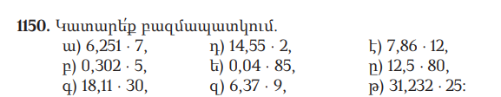

6.251x 7 = 43.757

0.302 x 5 = 1.51

18.11x 30 = 543.3

14.55 x 2 = 7.275

0.04 x 85 = 3.4

6.37 x 9 = 57.33

7.86 x12 = 94.32

12.5 x 80 = 1000

31,232 x 25 =780,8

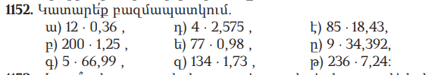

12 × 0,36=4,32

200 × 1,25=250

5 × 66,99=334,95

4 × 2,575=10,3

77 × 0,98=75,46

134 × 1,73=231,82

85 × 18,43=1 566,55

9 × 34,392=309,528

236 × 7,24=1 708,64

1155. Ճանապարհորդը 4 ժ քայլել է 5,2 կմ/ժ արագությամբ և 3 ժ՝ 4,8 կմ/ժ արագությամբ։ Որքա՞ն ճանապարհ է նա անցել։

5.2×4=20.8 կմ

4.8×3=14.4 կմ

20․8+14․4=35.2 կմ